Asp.Net Project with Database operations

Description: A sample project which explains about developing an Asp.Net Application in layered architecture. This application has all coding standards in place. This project is developed only for freshers and junior developers. It has Object Oriented Programming which helps Freshers and Junior developers to easily understand how project will be developed any software company.

Note: it is not an advanced project which means it doesn’t have Business Rules, Security, Roles etc, this application will helps to understand how to develop an application using classes and reusable data access objects etc.

Project Requirement:
Need to develop a tourism application with below operations available.
- Need to capture the Guides and Customer information
- Need to capture various location
- Any person can see locations available in application
- Application should have ability to update the existing data.
- Application should have static pages to display predefined content.

Below technologies are used in this application development
- ASP.NET
- C#.NET
- SQL Server
- HTML
- JavaScript
- Css

Concepts Covered in this project:

- Using Master Page.
- Using Validation controls to validate page.
- Binding grid-view with data-source controls and edit delete operations using gridview.
- Centralized session management
- Uploading files to server
- Using Query Strings
- Using Object Oriented Programming (Using classes and objects) to do database operations
- Inserting Data into database using stored procedures
- Updating/deleting Data into database using stored procedures
- Centralized procedure names management
- Using same screen for two different type of user’s database operations
- Centralized database operations
- Implementing coding when tables having Parent and Child relation (Added database diagram for reference ).
- OOPs in relational database operations (Parent and Child/ Primary and Foreign key operations)
- Maintaining database transactions in dot net while doing multiple database operations at once.
- Commit and roll back operations using dot net.
- Exception Handling (Not included logging)
- Writing Stored Procedures
- HTML & CSS

Architecture:

This application has two layer architecture as below

- Presentation Layer: Which will have all presentation related code and design.
- Data Access Layer: Which will have all database operations.

Presentation layer will communicate Data Access layer for all database operations such as Insert, Update, Delete and Get operations.

Below Image will helps you understand the application architecture.

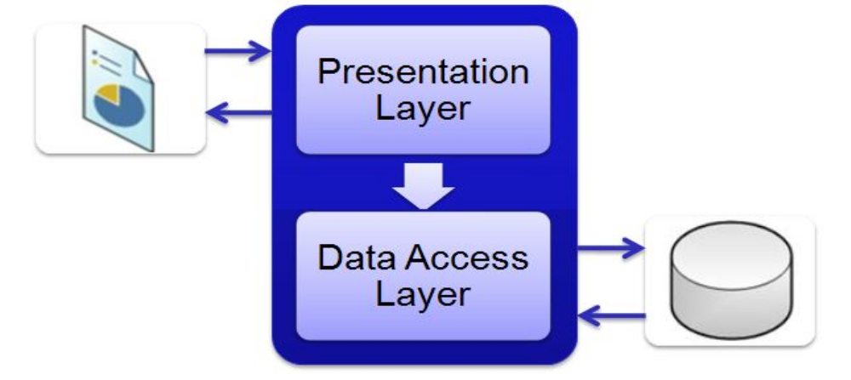
Database Details:
This application has 3 tables and stored procedures are also included in database. Below diagram will helps you to understand the database relations.
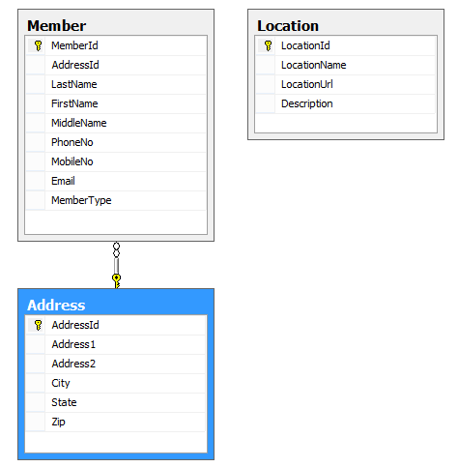
we need to configure the database before you open the application in browser.
We can configure database three ways
- Restore Backup file (Works for SQL Server 2008 R2 only )
- Execute the provided database scripts to create new database in your server
- Attach the database directly to your database server
- Keep database .mdf and .ldf files in your App_Data directory and use below connection string to connect the database
Connection String: <add name="ConnectionString1" connectionString="Data Source=.;AttachDbFilename=|DataDirectory|\Database.mdf;Integrated Security=True;User Instance=True" providerName="System.Data.SqlClient"/>
In the above case please check for data-source (. or ./sqlexpress or any other database instnace)

We are providing below database files and you can use any of the file as per your convinence
- “.bak” file (works only for Sql Server 2008 R2).
- “.mdf” and “.ldf” files
- Sql Script file.

Please look at http://onlinetrainingdotnet.com/ or mail me at trainingbyvasu@gmail.com for any clarifications.

